Trading

Lesson 1: Support and Resistance

🧠 What you MUST learn first (VERY IMPORTANT):
Before real money trading, learn:
1. 📊 Support & Resistance
Where price bounces or breaks

2. 📉 Trend
- Uptrend
- Downtrend
- Sideways

3. 🛑 Risk Management
👉 Never risk more than 1–2% of your money per trade
💰 Beginner Strategy (Simple Swing Trading)

- Pick strong coin/stock
- Wait for price dip (don’t chase high price)
- Enter small amount
- Set stop loss
- Target small profit (5–10%)

❌ Biggest mistake beginners do:
- No stop loss
- Overtrading
- Using big money early
- Emotional buying (“FOMO”)

📊 Support & Resistance:

- Support
- Price level where the market stops falling and goes up.
- Simple meaning:
- Buyers come in at this level
- Price bounces upward📈
- Think:
🟢 Support = FLOOR (bottom level)

- Resistance:
- Prive level where the market stops rising and goes down
- Simple meaning:
- Sellers come at this level
- Price falls downward📉
- Think:

🔴 Resistance = CEILING (top level)

📌 HOW PRICE MOVES:
Price usually moves like this:
👉 Up → hits Resistance → comes down
👉 Down → hits Support → goes up
This repeats again and again.

📈 HOW TO TRADE (SIMPLE RULES):
✅ BUY RULE
Buy near SUPPORT 🟢
Expect price to go up 📈
✅ SELL RULE
Sell near RESISTANCE 🔴
Expect price to go down 📉

⚠️ BREAKOUT (IMPORTANT):
📈 Resistance Break
Price goes ABOVE resistance
👉 Strong upward move possible

📉 Support Break
Price goes BELOW support
👉 Strong downward move possible

❌ BEGINNER MISTAKES:
- Buying in middle of price range
- No support/resistance marking
- No stop loss

🧠 EASY MEMORY:
Support = BUY zone 🟢 Resistance = SELL zone 🔴
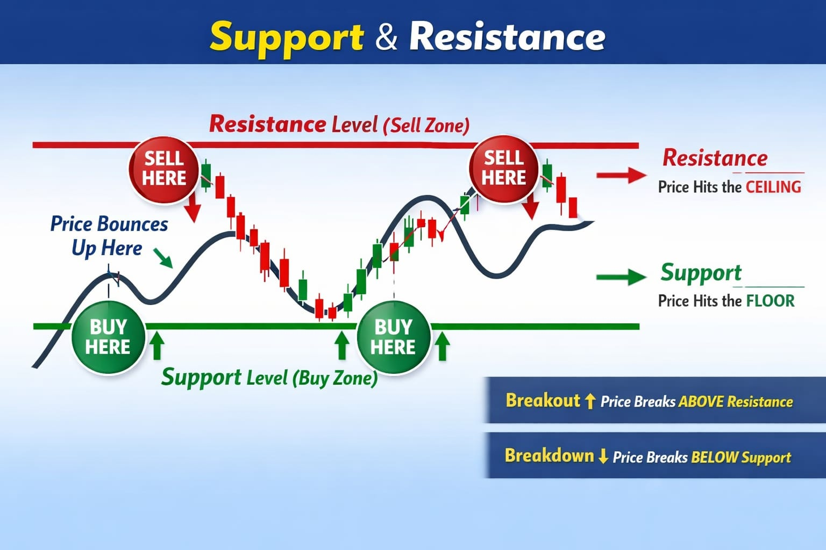

Lesson 2: Trend

  - 📉 TREND — VERY IMPORTANT

🔹 What is a TREND?
👉 Trend means direction of the market
Price does NOT move straight — it moves in direction.

📈 1. UPTREND
👉 Market is going UP overall
Structure:
Higher Highs 📈
Higher Lows 📈
Meaning:
Buyers are stronger 💪
Price keeps going up
Best action:
👉 BUY dips (near support)

📉 2. DOWNTREND
👉 Market is going DOWN overall
Structure:
Lower Highs 📉
Lower Lows 📉
Meaning:
Sellers are stronger
Price keeps falling
Best action:
👉 SELL or avoid buying
➡️ 3. SIDEWAYS (RANGE)
👉 Market moves between support and resistance
Meaning:
No clear direction
Price bounces up & down
Best action:
👉 Buy near support, sell near resistance

📌 SIMPLE IDENTIFICATION
📈 Uptrend:
Moves like:
↗ ↗ ↗
📉 Downtrend:
Moves like:
↘ ↘ ↘
➡️ Sideways:
Moves like:
↔ ↔ ↔

⚠️ GOLDEN RULE (VERY IMPORTANT)
👉 “Trade WITH the trend, not against it”

💰 HOW YOU USE THIS WITH SUPPORT/RESISTANCE
📈 Uptrend:
✔ Buy at support
✔ Hold longer
📉 Downtrend:
✔ Avoid buying
✔ Only sell or stay out

❌ BEGINNER MISTAKE
- Buying in downtrend thinking “cheap now”
- Fighting the market direction

🧠 EASY MEMORY
- Trend = direction
- Support = buy zone
- Resistance = sell zone

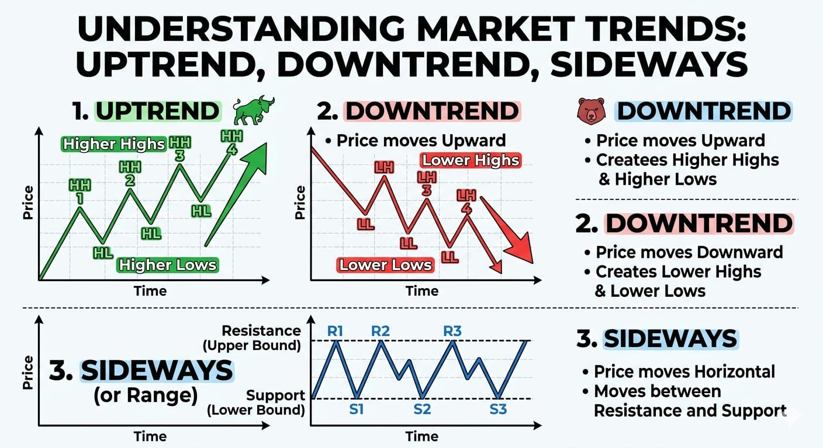

Lesson 3: Candlesticks basics

📊 CANDLESTICKS — VERY IMPORTANT

🔹 What is a candlestick?
👉 A candlestick shows price movement in a specific time
Example:
- 1 minute candle = price movement in 1 minute
- 1 hour candle = price movement in 1 hour
- 1 day candle = price movement in 1 day

🟢 GREEN CANDLE (BUYING PRESSURE)
👉 Price went UP
Meaning:
- Buyers are stronger 💪
- Closing price is higher than opening
Simple:
🟢 Green = UP move

🔴 RED CANDLE (SELLING PRESSURE)
👉 Price went DOWN
Meaning:
- Sellers are stronger
- Closing price is lower than opening
Simple:
🔴 Red = DOWN move

📌 CANDLE STRUCTURE
Each candle has 3 parts:

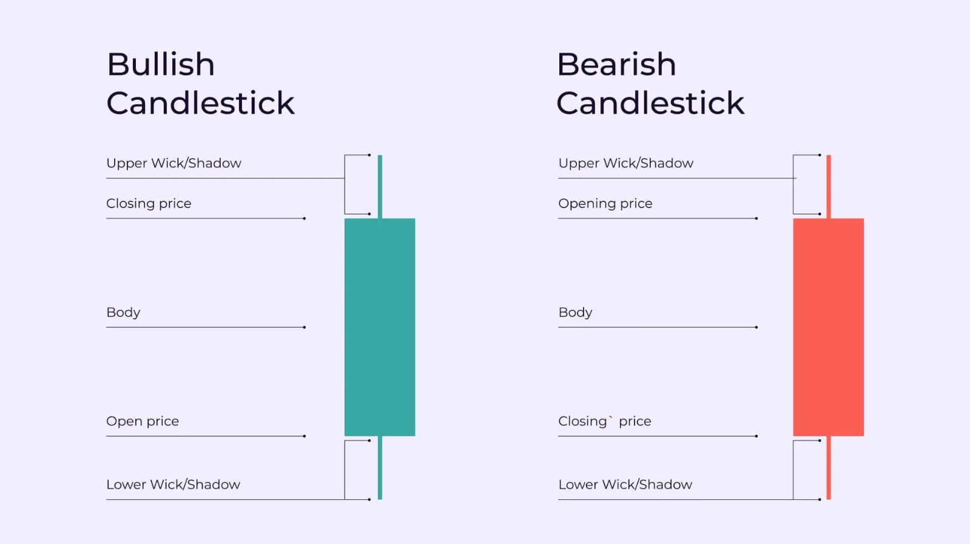

1. BODY
👉 Main thick part
Shows open → close movement
2. WICK (Shadow)
👉 Thin lines above/below
Shows highest & lowest price

📈 SIMPLE EXAMPLE
Green candle:
Open = 100
Close = 110
👉 Price went UP
Red candle:
Open = 110
Close = 100
👉 Price went DOWN

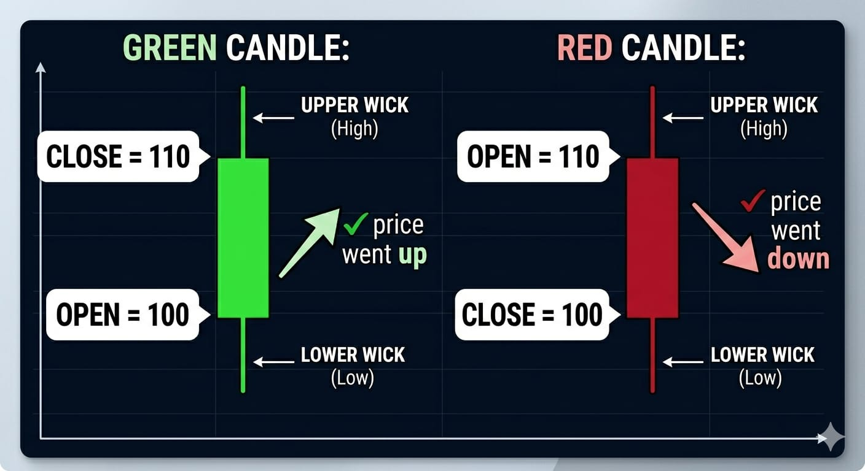

📊 HOW TRADERS USE CANDLES
🟢 Strong BUY signal:
- Big green candles
- Small red candles
👉 Buyers dominating

🔴 Strong SELL signal:
- Big red candles
- Small green candles
👉 Sellers dominating

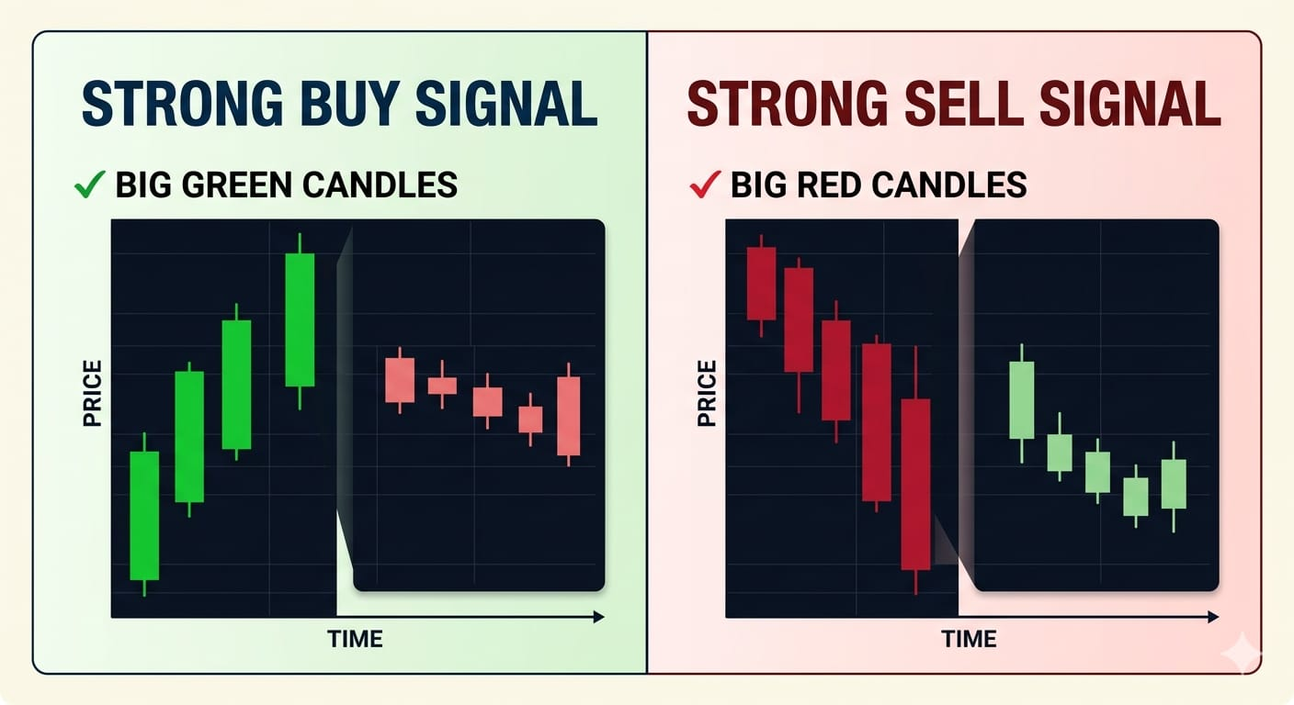

⚠️ IMPORTANT PATTERN IDEA
- Long wick = rejection
- Price tried going up/down
- But got pushed back
👉 Shows strong support/resistance area

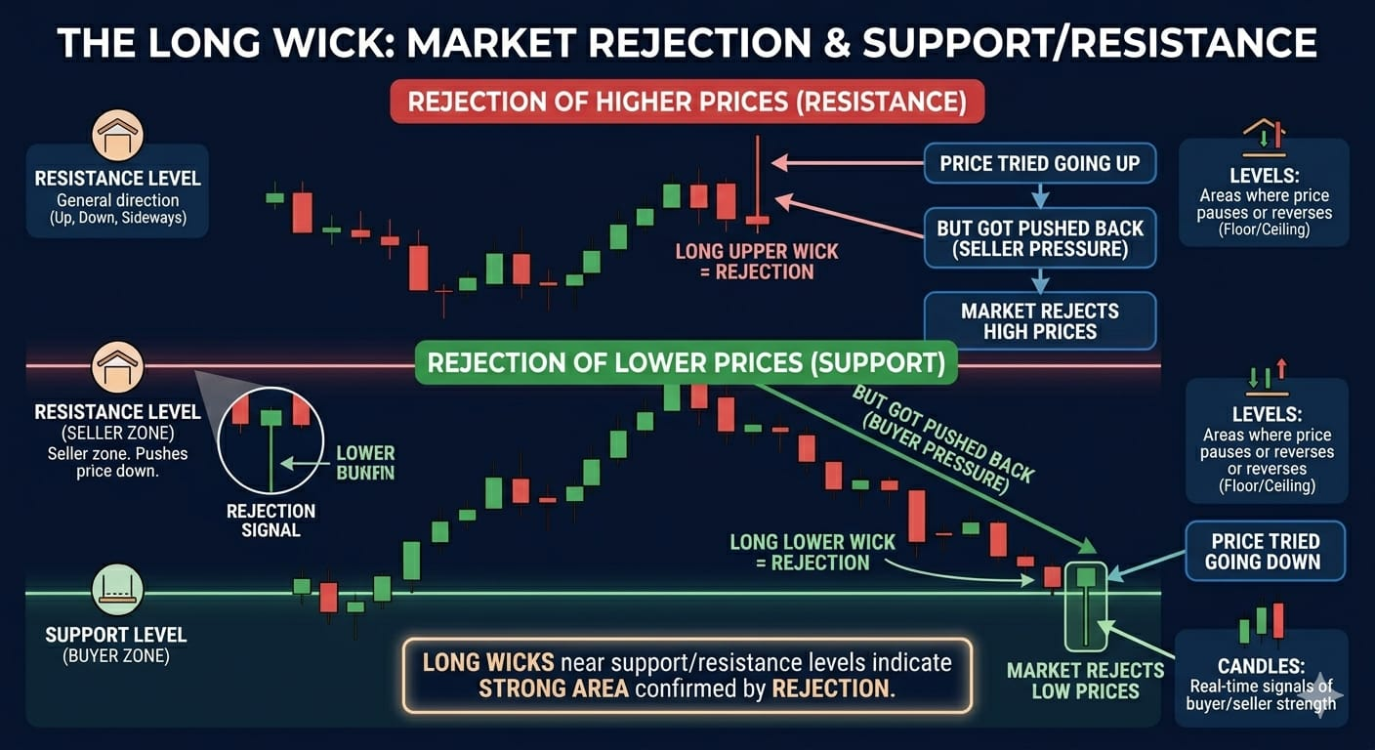

🧠 EASY MEMORY
🟢 Green = buyers win
🔴 Red = sellers win
Wick = rejection zone

💰 HOW THIS CONNECTS TO YOUR STRATEGY
Now combine everything:
- Trend 📈📉
- Support/Resistance 🟢🔴
- Candles 🟢🔴
👉 This is how real trading decisions are made

❌ BEGINNER MISTAKE
- Thinking one candle = signal
- Not looking at trend
- Ignoring support/resistance

Lesson 4: Entry, Stop Loss, Target

Note: This is where you actually start thinking like a trader.

📊 1. ENTRY (When to BUY):
👉 You should NOT buy randomly.
✅ Best entry rule:
Price near Support 🟢
Trend = Uptrend 📈 (or sideways)
Look for long lower wick (rejection)

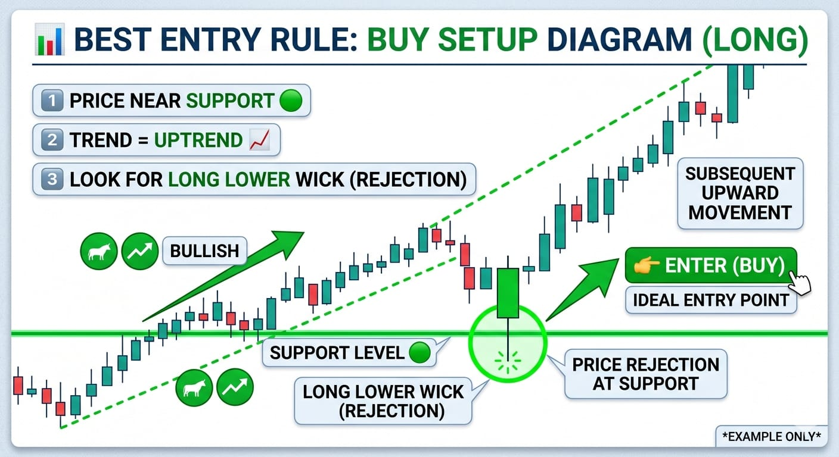
👉 Then you ENTER (buy)

📌 Example:
Support = 100
Price comes to 102–100
Shows lower wick

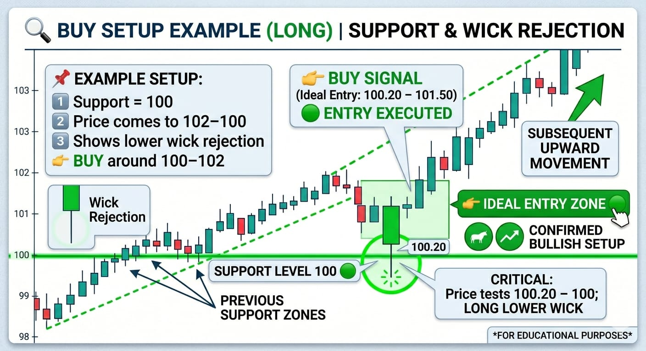
👉 You BUY around 100–102

🛑 2. STOP LOSS (Very important)
👉 This protects your money
✅ Rule:
Place stop loss below support
📌 Example:
Support = 100
You buy at 102
👉 Stop loss = 95–98
✔ If price falls → small loss
❌ Without this → big loss
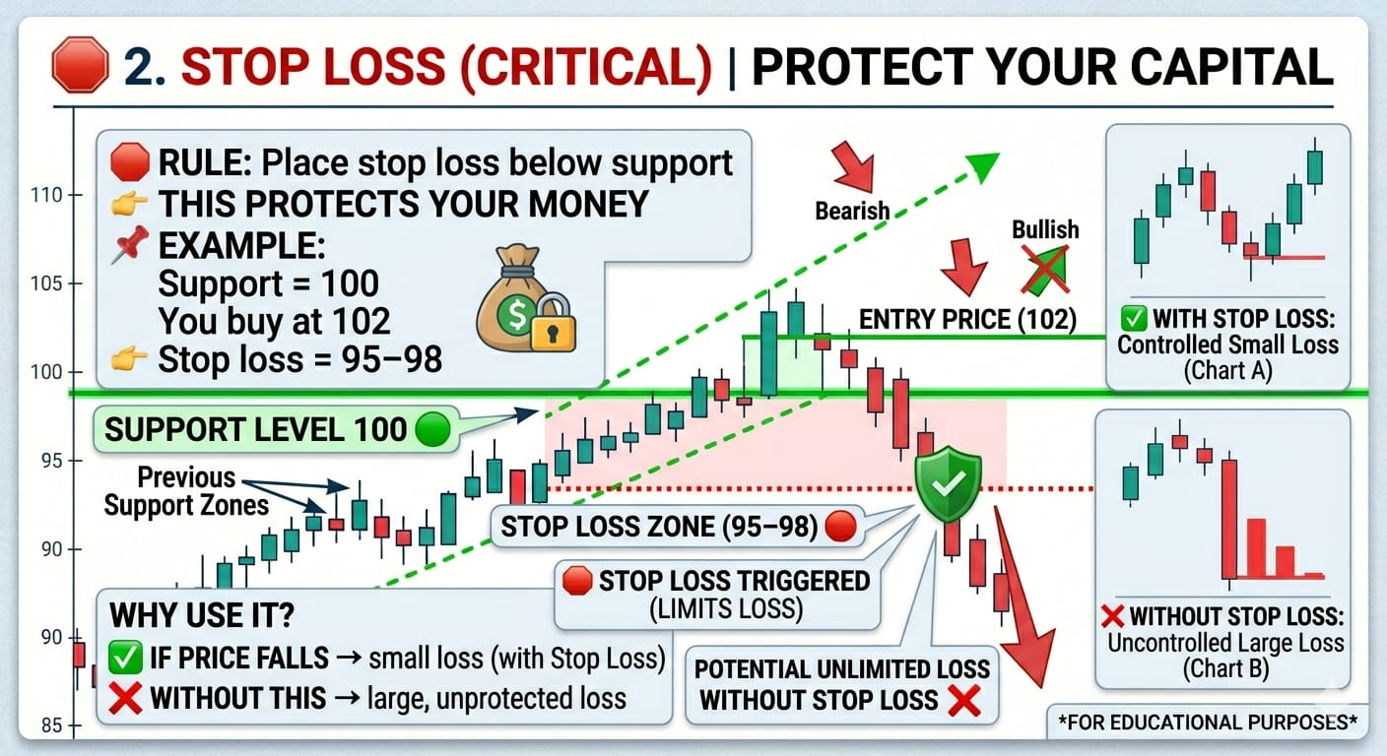

🎯 3. TARGET (Take profit)
👉 Where you exit with profit

✅ Rule:
Target near Resistance 🔴
📌 Example:
Resistance = 120
You buy at 102
👉 Target = 115–120
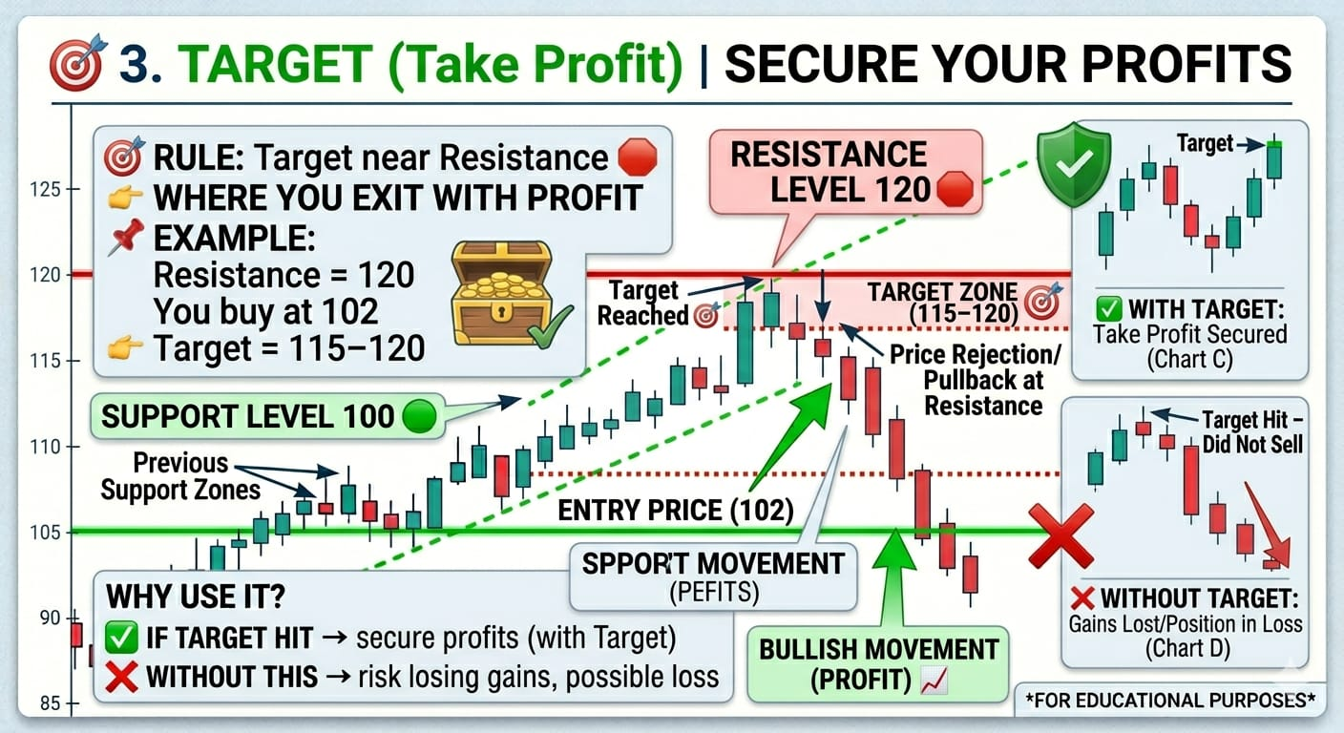

📈 FULL TRADE SETUP (IMPORTANT)
👉 This is your complete plan:
Entry → near support
Stop Loss → below support
Target → near resistance

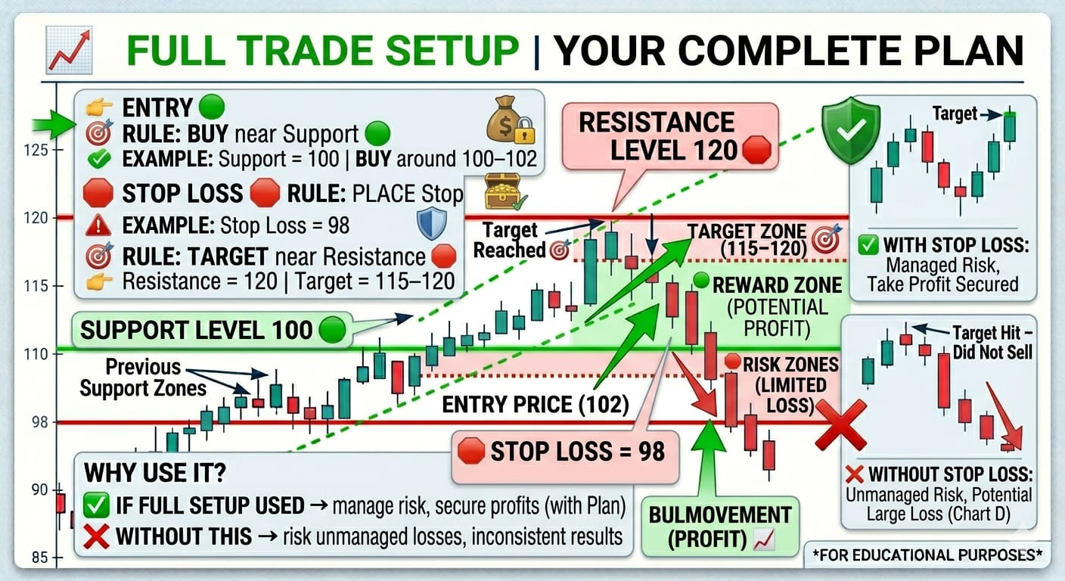
⚖️ RISK MANAGEMENT (GOLDEN RULE)
👉 Always follow this:
Risk small ❗
Reward bigger ❗
Example:
Risk = ₹500
Profit target = ₹1000
👉 Good trade 👍
❌ BEGINNER MISTAKES
No stop loss ❌
Entering in middle ❌
Greed (not booking profit) ❌
Fear (exiting early) ❌
🧠 EASY MEMORY
Entry = Support
Stop loss = Below support
Target = Resistance
🔥 FINAL TRUTH
👉 You don’t need many strategies
👉 Just master this ONE setup first

